IPIC PATENT AGENT TRAINING COURSE
DRAFTING & PROSECUTION
EXERCISE # 6 - DRAFTING
Your client manufactures optical scopes for sniper and hunting rifles. He writes to you as follows:
“I’d like you to file a patent application for me to protect my invention. In order to enhance the comfort, convenience and utility of optical scopes as well as telescopes, binoculars and other such optical apparatus, these devices can be equipped with an eyeguard to interface between the user's eye and the optical instrument. Eyeguards often take the form of a flexible rubber rim or cup extending from the eyepiece of the optical instrument. The eyeguard typically allows the user to comfortably position his eye against the instrument, assists the user in maintaining the proper eye relief distance, (i.e., the distance from the eye lens of the optical instrument to the user's eyeball) to provide the user with full field of view, and to shield the user's eye from ambient or reflected light which may distract from the image transmitted through the optical instrument.
“My invention provides an eyeguard which automatically protects an eye-end lens of an optical instrument from dirt, dust and airborne contaminants when not in use. Another object of the present invention is to provide an eyeguard which automatically prevents light from entering into or exiting from the eye-end lens of an optical instrument when not in use. My invention also provides an eyeguard which requires lower user eye force to activate. Additionally, my invention provides an eyeguard which requires reduced user eye movement to activate. Also, my invention provides an eyeguard which can be moulded as single piece of resilient material, out of rubber or the like.”
Your client has done an online search and uncovered four patents (US Patent No. 3,715,149, Us Patent No. 4,415,242, US Patent No. 4,630,903 and US Patent No. 5,408,359. Copies of these patents are enclosed.
“Referring to the Figures 1A and 1B, which provide side plan cutaway views of my invention, the invention provides a resilient eyeguard 10 having an instrument-end member 12, an eye-end member 14, and a diaphragm 16 located there between. The instrument-end member 12 has a first portion 18 adapted for connecting the eyeguard to the optical instrument and a second portion comprising a first flexible annular hinge 20. The eye-end member 14 has a front portion comprising a second flexible annular hinge 22 having a diameter less than that of the first flexible annular hinge 20 and rear portion comprising a disk 24 adapted to interface with the region around the eye of the user.
“The diaphragm 16 comprises a plurality of segments 26, each having a front side 28 joined to the first flexible annular hinge 20 and a rear side 30 joined to the second flexible annular hinge 22. The diaphragm 16 has a closed state and an open state. When in the closed state, the diaphragm segments 26 are configured so as to block the passage of light rays through the eyepiece 10, whereas when in the open state, the diaphragm segments 26 are configured so as to allow the passage of light rays through the eyepiece. By pressing the eye against the eye-end member 14, the user can cause relative motion between the instrument-end member 12 and the eye-end member 14 of the eyeguard 10 such that the eyeguard will be deformed at the first and second annular hinge, 20, 22. This causes the diaphragm segments 26 to move from a closed state to an open state as the user pushes against the eye-end member 14. When the user releases pressure from the eye-end member 14, the resilience of the hinge material causes the eye-end member 14 to return to its original position such that the first and second annular hinges 20, 22 return to their original position and the diaphragm segments 26 return to their normal closed position.
“Figures 2A through 2C provide perspective views of my invention.”

Exercise
Draft a patent application to protect the invention, including appropriate reference numbers where needed.
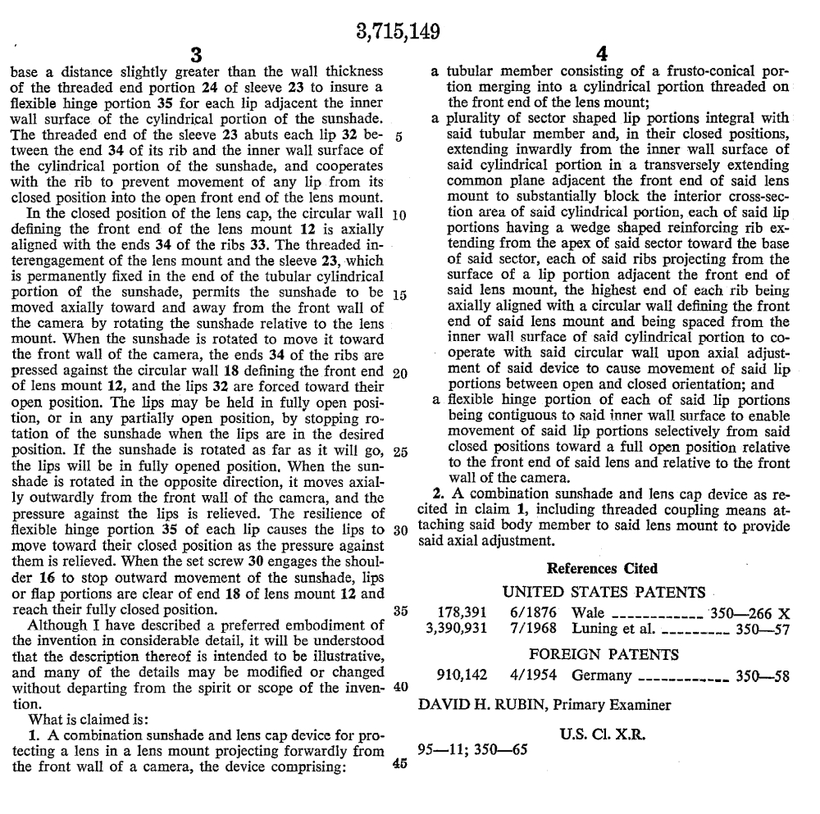

x,xxx,149


